|  |  |
| --- | --- |
| Name: | Class: |

**➀Read and match.** Score / 5

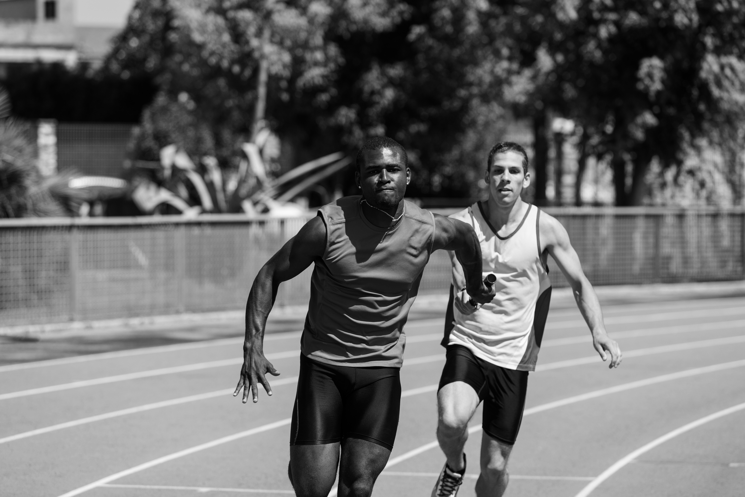➊ They usually wear shorts and a T-shirt because they get very hot, and because these clothes are easy to move in. But the most important thing to wear is comfortable shoes.

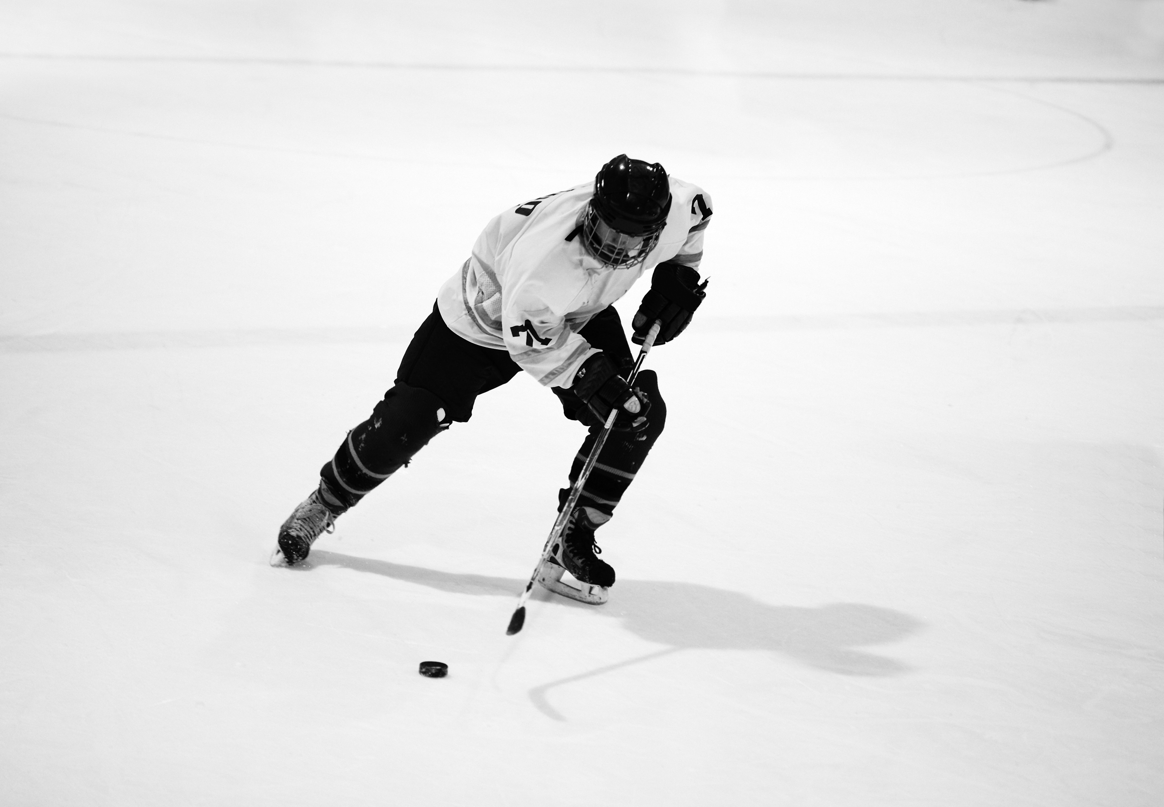 ➋ His uniform is a T-shirt and shorts. He also wears leather gloves because he has to catch the ball. He has long cotton socks, and he wears leather shoes.

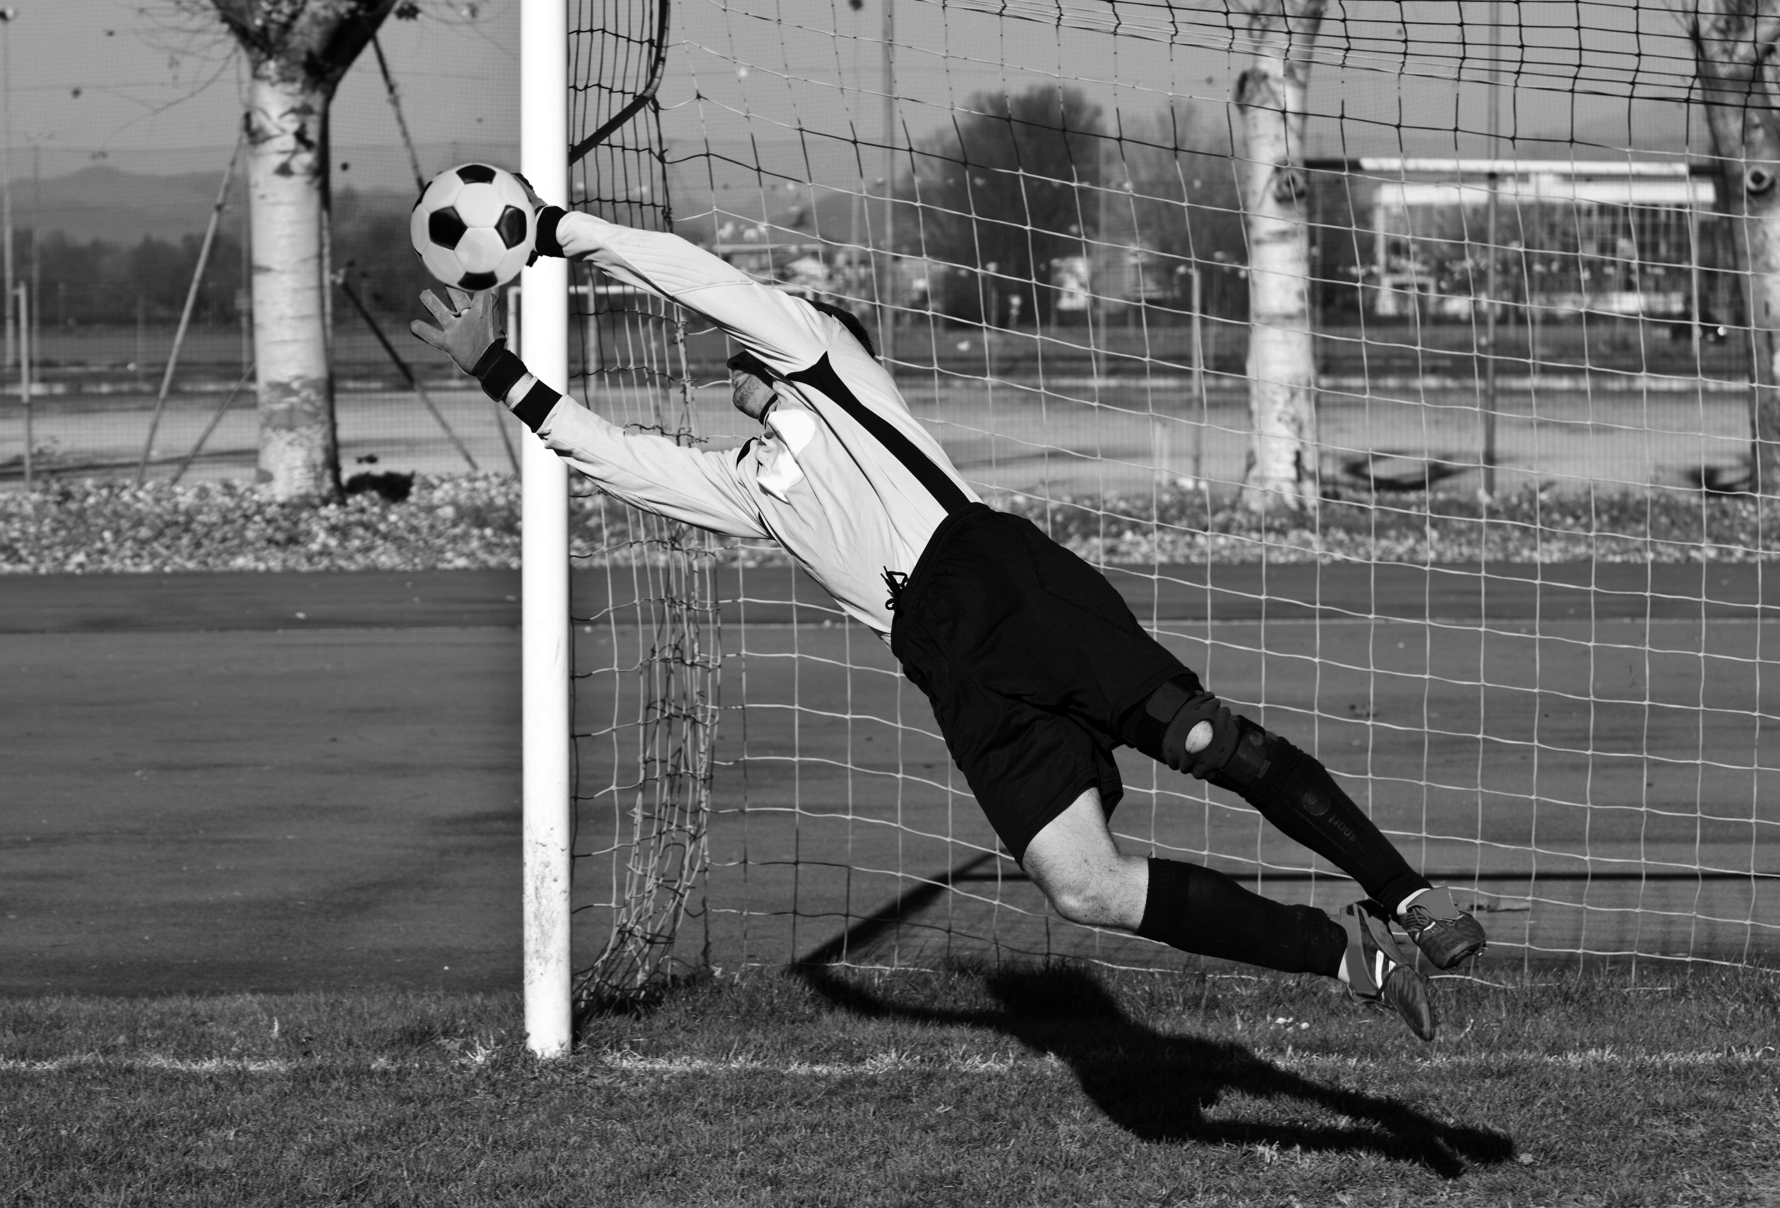 ➌ He wears cotton pants with pockets and a belt. His sweater is made of wool. He also wears leather shoes and a cap. His uniform is light because he walks a lot.

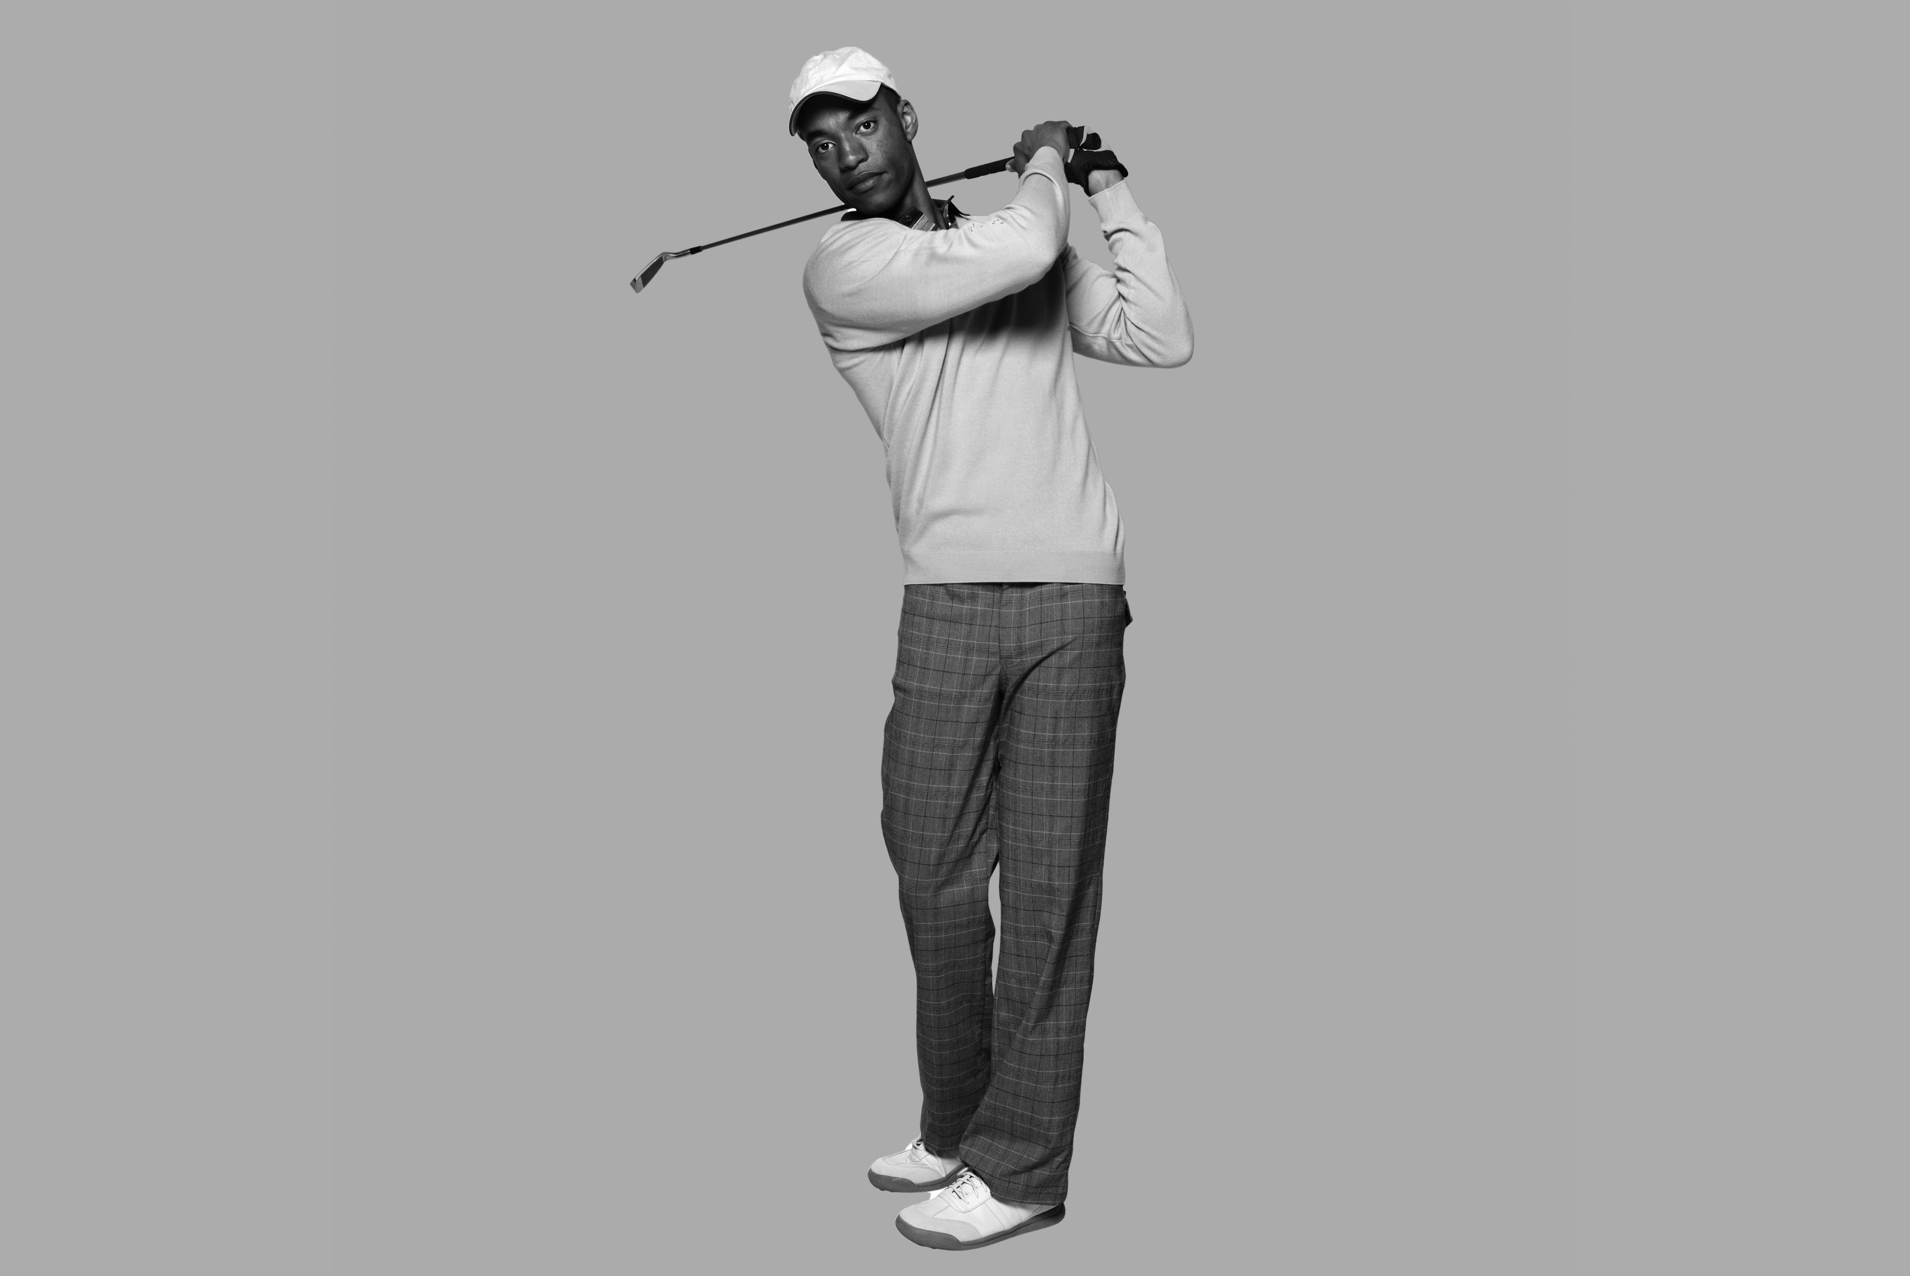 ➍ His uniform is very big and heavy. He wears the colors of his team. He skates very fast on the ice, and his uniform helps protect him. He has to wear a helmet and thick gloves.

f

e

d

c

a

b

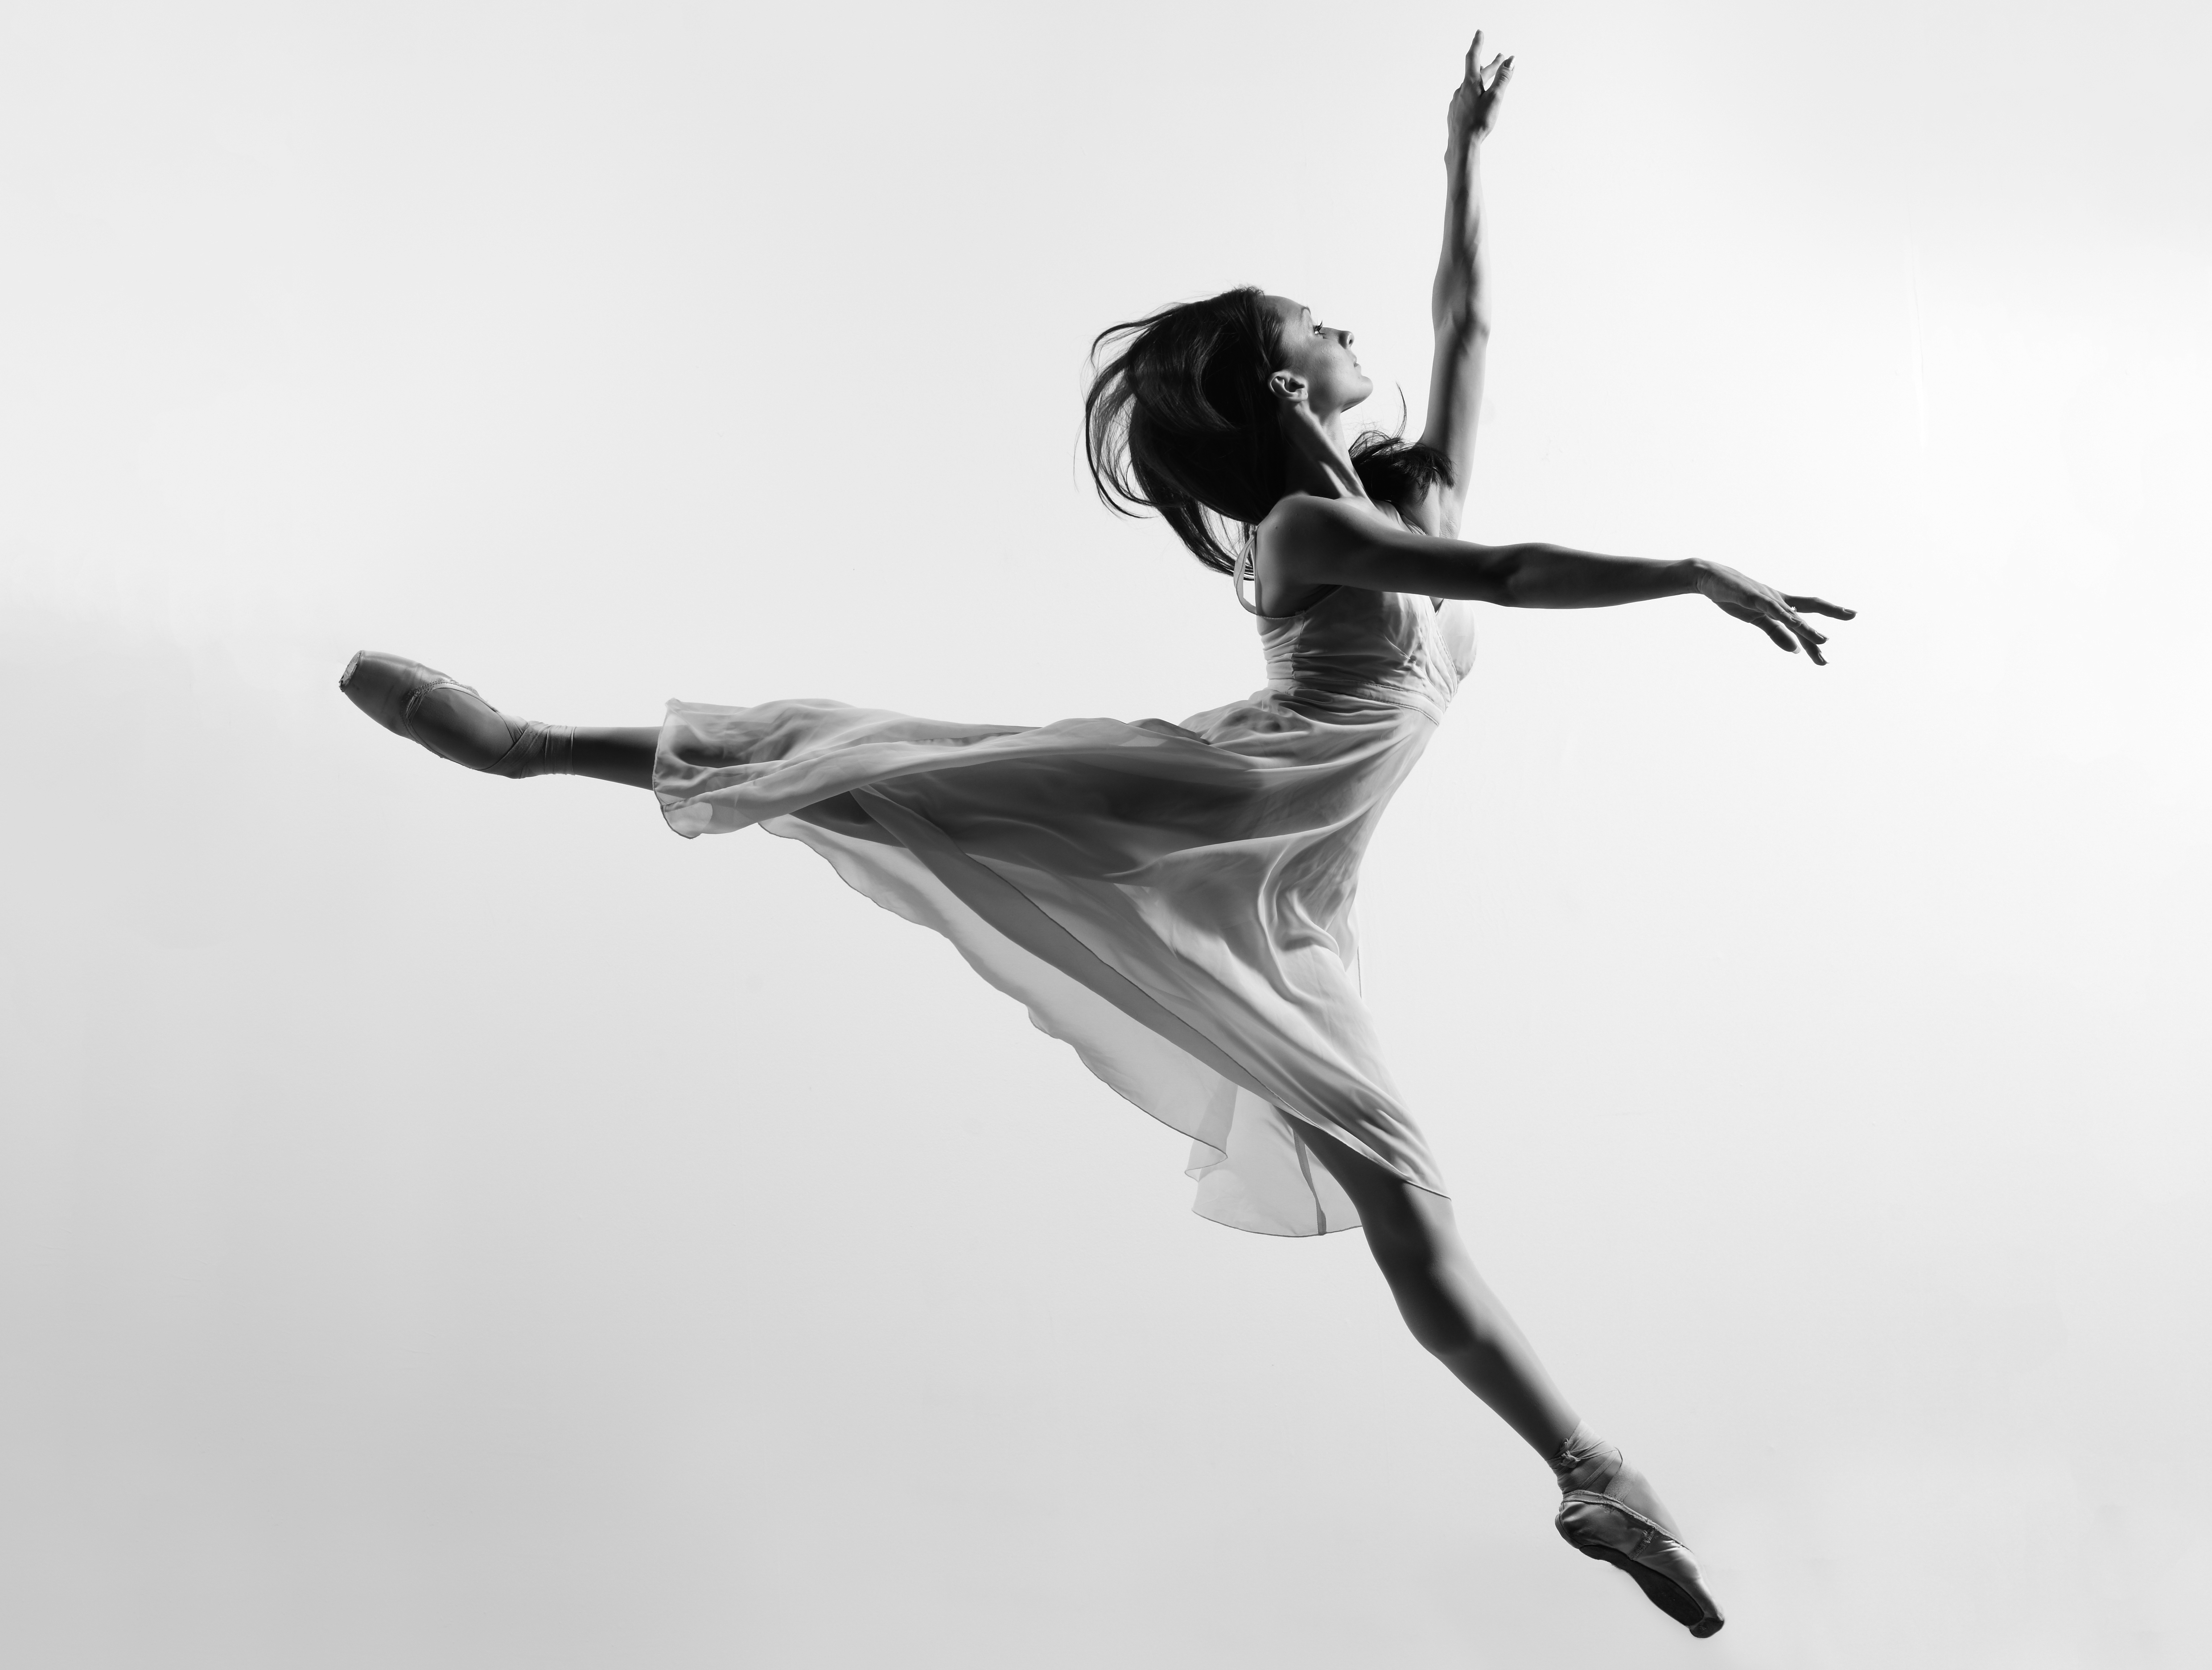 ➎ He has very soft, warm clothes. He wears gloves because   
it is cold in the mountains. He also wears a helmet because   
his hobby can be dangerous.

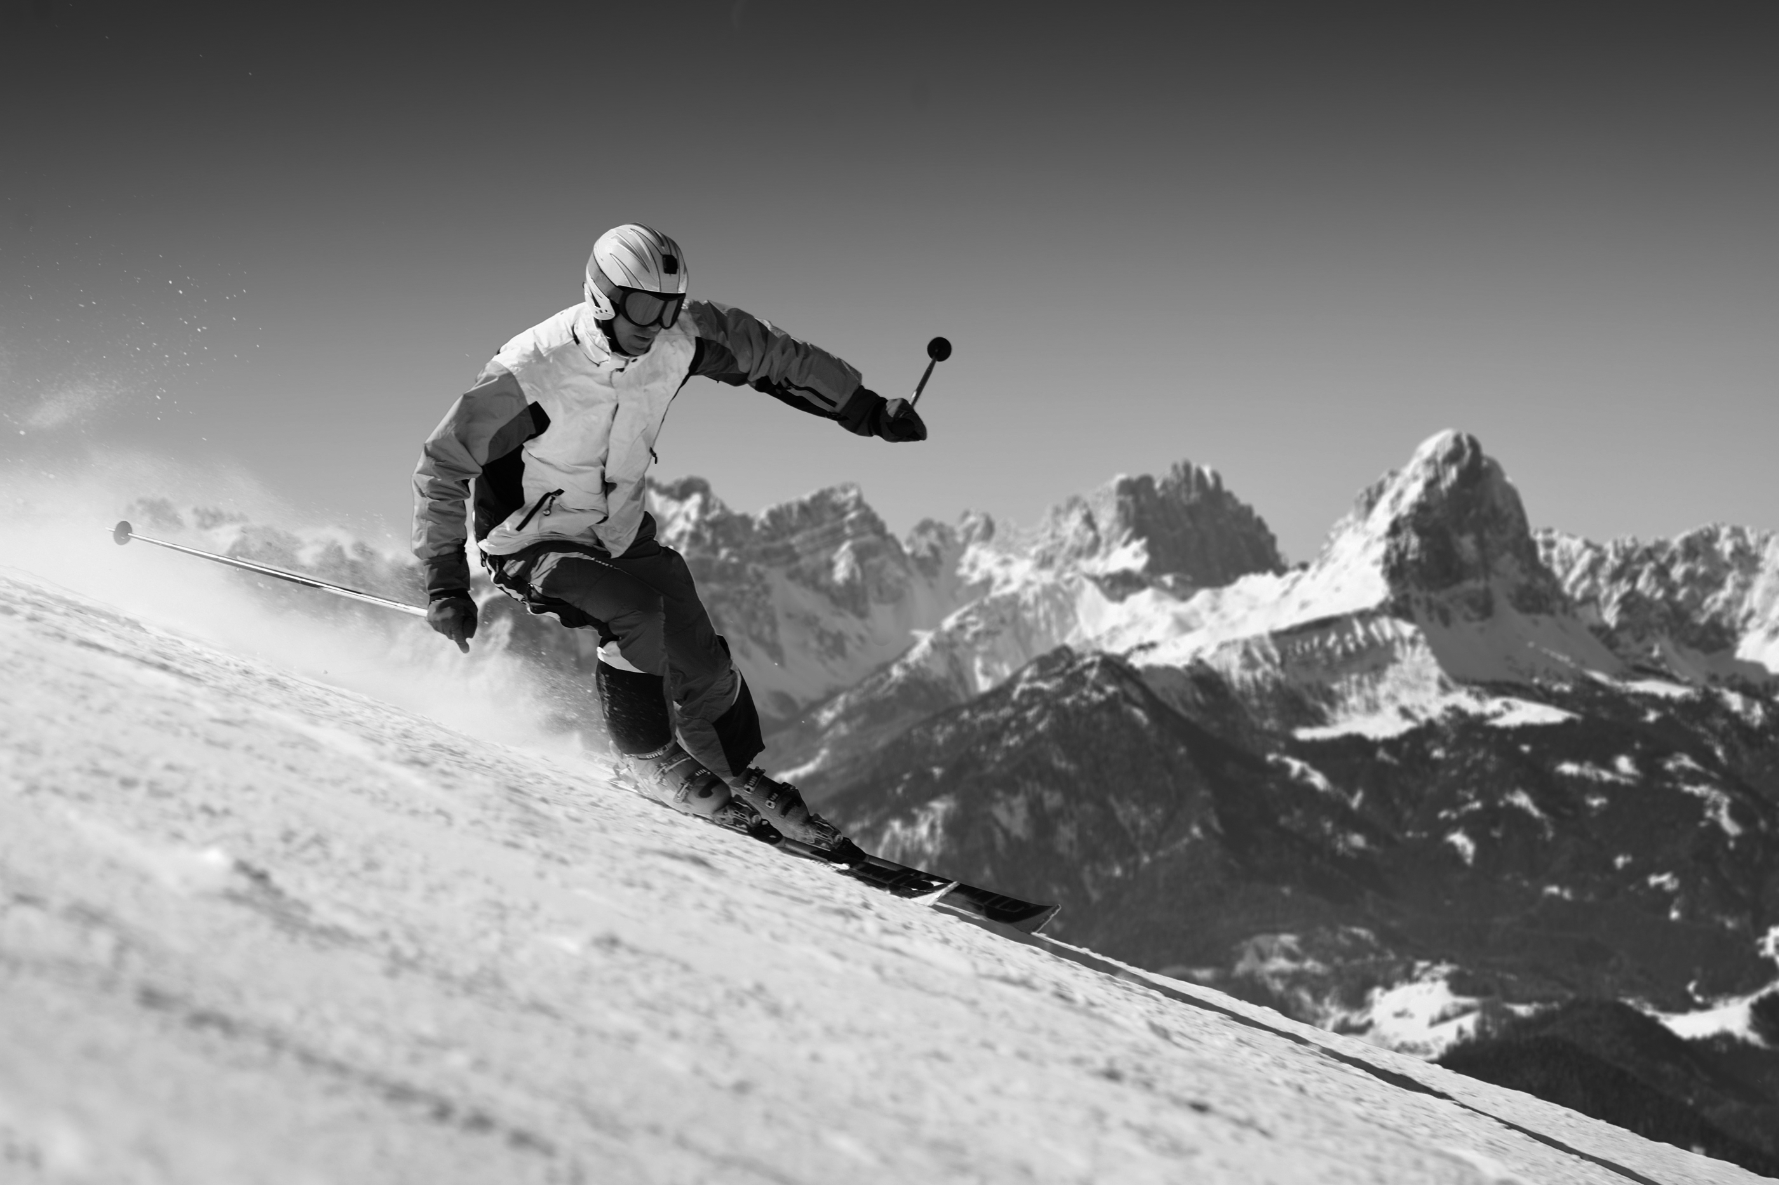 ➏ She wears a skirt and tights. Her uniform doesn't have any pockets because she doesn’t carry anything. Her clothes are thin and light because she moves a lot.



**➁ Listen and check (🗸) or put an X in the box.**  Score / 10



➊ It might not be a friend outside the door.



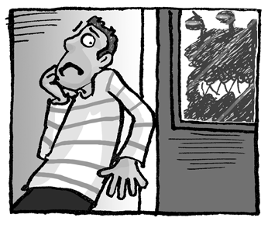➋ She may not have gloves.



➌ She might be unhappy.



➍ He may be with a friend.



➎ He might be thirsty.



➏ She may be bored.

Total unit score / 15